CASE STUDY 2: Hospital Patient Record System
// Creating Database
use HospitalDB
// Creating Collection
db.createCollection("patients")
// Showing Collections
show collections
// Inserting One Document
db.patients.insertOne({
pid:1,
name:"Ravi",
age:45,
disease:"Diabetes",
city:"Chennai"
})
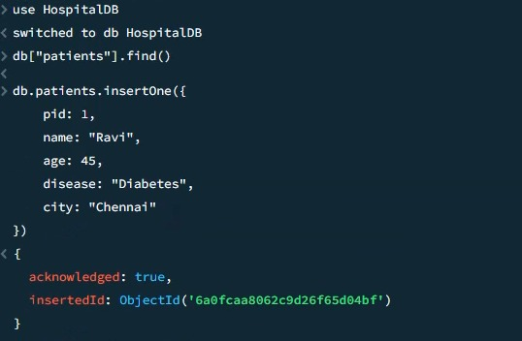
// Inserting Multiple Documents
db.patients.insertMany([
{
pid:2,
name:"Anita",
age:30,
disease:"Fever",
city:"Madurai"
},
{
pid:3,
name:"Kumar",
age:50,
disease:"BP",
city:"Trichy"
}
])
// Creating Unique Index
db.patients.createIndex({pid:1},{unique:true})
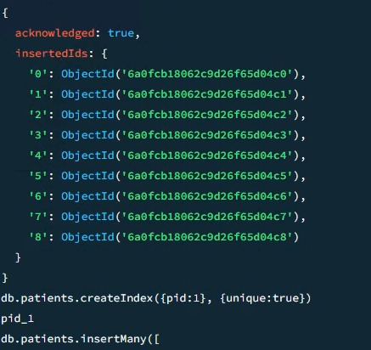
// Handling Duplicate IDs
db.patients.insertMany([
{
pid:11,
name:"Kiran",
age:38,
disease:"Fever",
city:"Chennai"
},
{
pid:1,
name:"Duplicate",
age:44,
disease:"BP",
city:"Madurai"
}
],{ordered:false})
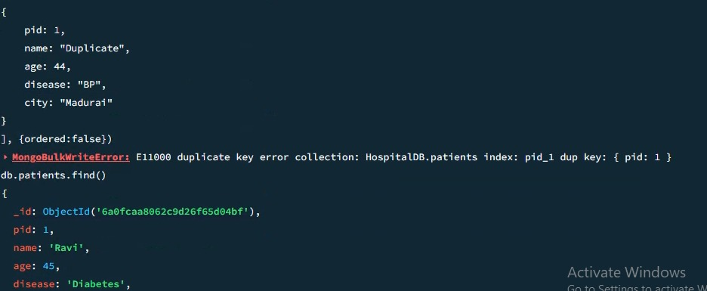
// Retrieving One Document
db.patients.findOne({pid:1})
// Filtering by Disease
db.patients.find({disease:"Diabetes"})
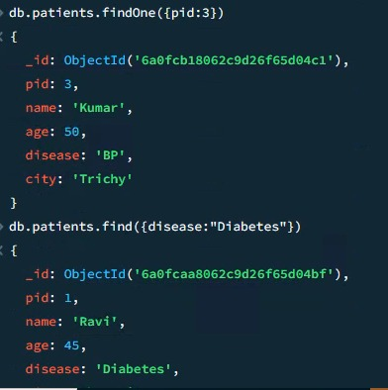
// Filtering by City
db.patients.find({city:"Chennai"})
// Filtering by Age Range
db.patients.find({
age:{
$gte:30,
$lte:50
}
})
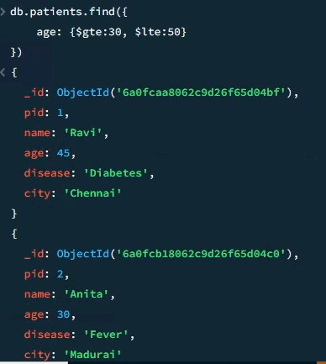
// Displaying Selected Fields
db.patients.find(
{},
{
_id:0,
name:1,
disease:1
}
)
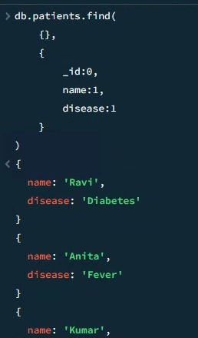
// Dropping Collection
db.patients.drop()
// Dropping Database
db.dropDatabase()
